
Name:

MATHEMATICS SPECIALIST 3CD

SEMESTER 1 2010

TEST 3

 | Questions | Reading Time | Working Time | Marks | Score
Calculator Free | 1 – 2 | 3 minutes | 20 minutes | 15
Calculator Assumed | 3 - 5 | 5 minutes | 35 minutes | 28
Total |  |  |  | 43

1. [5 marks]

Prove the following: 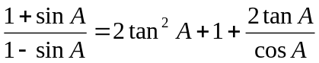

2. [10 marks]

Find the equation of the tangents to the curve 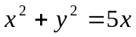 where the line y = x – 2 intersects it.

Name:

MATHEMATICS SPECIALIST 3CD

SEMESTER 1 2010

TEST 3

 | Questions | Reading Time | Working Time | Marks | Score
Calculator Free | 1 – 2 | 3 minutes | 20 minutes | 15
Calculator Assumed | 3 - 5 | 5 minutes | 35 minutes | 28
Total |  |  |  | 43

3. [3 marks]

Find a counter example to the claim: ‘A quadratic function of x is a function in which the highest power of x is 2’.

4. [4, 3, 4 marks]

(a) If 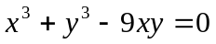, determine  at (3, 0).

(b) Find if 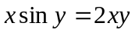

(c) If 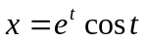 and 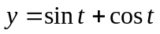, determine in its simplest form.

5. [2, 3, 4, 5 marks]

(a) Determine 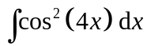

(b) Determine 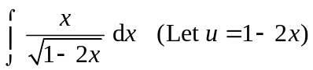

(c) Evaluate 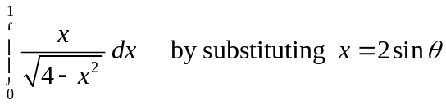

(d) The figure shows part of the curve y = sin x. Calculate the exact area of the shaded region.
